Monetization Ideas

Random loot Chests:

Players can purchase a loot box or something similar in a different theme, which contains different items and the player is given a random item from a selected group/set. This also forces players to use it many times to get the item which they want because they know what the “loot box” contains.

Seasonal Items:

Having limited time items which players can buy. Players will buy this as they know it does not last forever and this gives it a false/higher value due to the limited quantity of them.

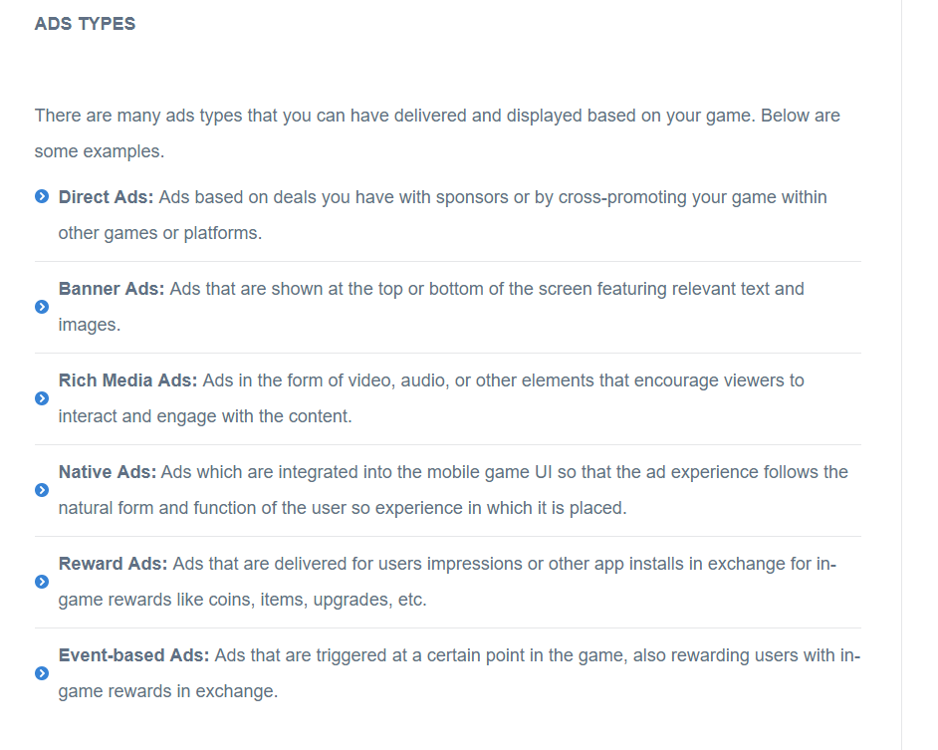

References:

https://www.gamasutra.com/blogs/ChrisCobb/20171116/309740/Video_Game_Monetization_Strategies.php

https://instabug.com/blog/mobile-game-monetization/